A Proposal on

Interactive Mathematics Visualization Tools

Submitted By:
Nikesh Adhikari (79214013)
Bishal Pandey (79214007)
Milan Kumar Karki (79214012)

Submitted To:
BICTE Program
Sukuna Multiple Campus
Sundarharaincha-12, Morang

Date:
____________________

Table of Contents
Table of Contents 2
CHAPTER-1: INTRODUCTION 3
1.1 Background of Study 3
1.2 Problem Statement 4
1.3 Objectives 4
1.4 Scope and Limitations 4
1.4.1 Scope 4
1.4.2 Limitations 4
CHAPTER-2: METHODOLOGY 5
2.1 Requirement Identification 5
2.1.1 Study of Existing System 5
2.1.2 Limitations of Existing System 6
2.1.3 Requirement Collection 6
2.1.4 Feasibility Study 6
CHAPTER-3: SYSTEM DESIGN AND TOOLS 7
3.1 Analysis and Design Tools 7
3.2 Implementation Tools 7
3.2.1 Frontend 7
3.2.2 Backend 8
3.2.3 Libraries 8
CHAPTER-4: HIGH-LEVEL DESIGN OF THE SYSTEM 8
4.1 Use Case Diagram 8
4.2 Entity Diagram 9
4.3 System FlowChart 10
CHAPTER-5: GANTT CHART 11
CHAPTER-6: EXPECTED OUTCOMES 11
CHAPTER-7: CONCLUSION 11

INTRODUCTION

Background of Study
Mathematics often involves abstract concepts that are difficult to understand through static textbooks alone. Students frequently struggle to visualize equations, graphs, and transformations. Interactive visualization tools can bridge this gap by providing dynamic, real-time graphical representations.
According to (Arcavi, 2003), visualization plays a crucial cognitive role by bridging the gap between symbolic representation and conceptual understanding, enabling learners to better interpret mathematical structures that are otherwise difficult to grasp through algebraic expressions alone. The ability to observe real-time changes in graphs based on parameter adjustments transforms passive learning into active exploration.
The role of visual representations in the learning of mathematics. Educational Studies in Mathematics .
Building on this, (Markus Hohenwarter, 2004) demonstrated through empirical studies that interactive mathematical software such as GeoGebra significantly improves students’ problem-solving abilities and conceptual understanding. Their findings revealed that learners who engaged with dynamic visual tools performed better in assessments compared to those using traditional static methods.
Furthermore, (Tall, 1991) emphasized the importance of computer-based environments in developing advanced mathematical thinking. Interactive systems allow learners to experiment with functions, explore limits, and visualize derivatives and integrals, which fosters deeper cognitive engagement beyond rote memorization.
In addition, (Hunter, 2007) introduced Matplotlib as a powerful visualization tool that enables the graphical representation of mathematical functions and data, making it an essential component in scientific computing and educational tools. It provides flexibility for plotting complex equations and supports dynamic updates in visualization systems.
Moreover, (Inc., 2023) highlights the importance of interactive visualization in modern applications. Plotly enables real-time, browser-based graphical rendering with user interaction capabilities such as zooming, panning, and parameter adjustments, making it highly suitable for educational visualization systems.
(Inc., 2023), Plotly Documentation. This project proposes the development of an interactive mathematics visualization system using Python. The system will allow users to manipulate variables and instantly observe changes in graphs and mathematical models, making learning more intuitive and engaging.

Problem Statement
Traditional methods of teaching mathematics rely heavily on static diagrams and theoretical explanations, which:
- Make it difficult for students to grasp abstract concepts
- Do not support real-time interaction or experimentation
- Limit student engagement and exploration
There is a need for an interactive system that enables users to visualize and experiment with mathematical concepts dynamically.

Objectives
- To design and develop an interactive mathematical visualization system.

Scope and Limitations

Scope
- Visualization of algebraic functions (linear, quadratic)
- Graphical representation of calculus concepts (derivatives, integrals)
- Basic geometry visualization
- Interactive user interface for input and control
- Suitable for students and educators

Limitations
- Limited to predefined mathematical models initially
- May not support highly advanced mathematical computations
- Requires basic computer literacy
- Performance may slow with complex graphs

METHODOLOGY

Requirement Identification

Study of Existing System
Existing systems currently used for mathematics visualization and learning include several popular platforms and software applications:

GeoGebra
(Paragraph kun company ; what works and features limitation)
- Dynamic graph plotting and geometry visualization
- Interactive algebra and calculus tools
- Real-time parameter adjustment using sliders
- Supports classroom teaching and online learning [reference)

Demos Graphing Calculator
- Interactive graph plotting for algebra and calculus
- Easy-to-use web-based interface
- Real-time equation visualization
- Supports animations and mathematical explorations

MATLAB
- Advanced mathematical computation and visualization
- Numerical analysis and graph generation
- Widely used in engineering and scientific research
- Supports matrix operations and simulations

Wolfram Mathematica
- Symbolic computation and advanced visualization
- Interactive mathematical modeling
- Built-in support for calculus, algebra, and statistics
- High computational accuracy

Limitations of Existing System
[Pragraph]
- Lack of interactivity
- No real-time updates
- Limited visualization capabilities

Requirement Collection

Requirements were gathered based on:
[Pragraph]
- Student learning difficulties
- Teacher feedback • Educational needs

Functional Requirements:
[Pragraph]
- Input mathematical equations
- Display graphs dynamically
- Adjust parameters using sliders
- Show real-time updates

Non-Functional Requirements:
[Pragraph]
- Easy to use interface
- Fast response time
- Accuracy of calculations

Feasibility Study

Technical Feasibility
[Pragraph]
- Python provides strong libraries (NumPy, Matplotlib, Plotly)
- System can run on standard computers
- Easy integration of UI frameworks
Conclusion: Technically feasible

Operational Feasibility
[Pragraph]
- Easy for students and teachers to use
- Minimal training required
- Improves teaching-learning process
Conclusion: Operationally feasible

Economic Feasibility
[Pragraph]
- Uses open-source tools (Python libraries)
- No licensing cost
- Low development cost
Conclusion: Economically feasible

SYSTEM DESIGN AND TOOLS
[Pragraph]

Analysis and Design Tools
- Flowcharts
- Use Case Diagrams
- UML Diagrams

Implementation Tools

Frontend
- HTML, CSS

Backend
- Python Django

Libraries
- NumPy
- Matplotlib
- SymPy
- Plotly

HIGH-LEVEL DESIGN OF THE SYSTEM

Use Case Diagram
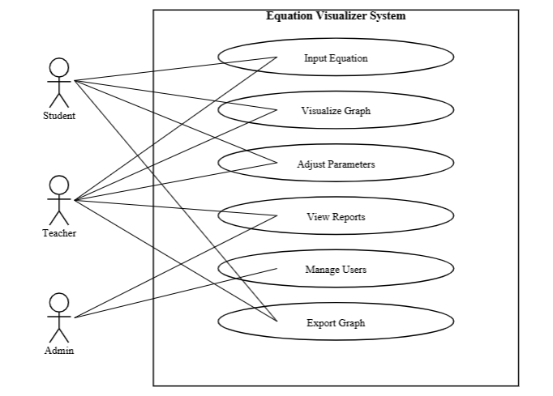
[Pragraph]

Entity Diagram
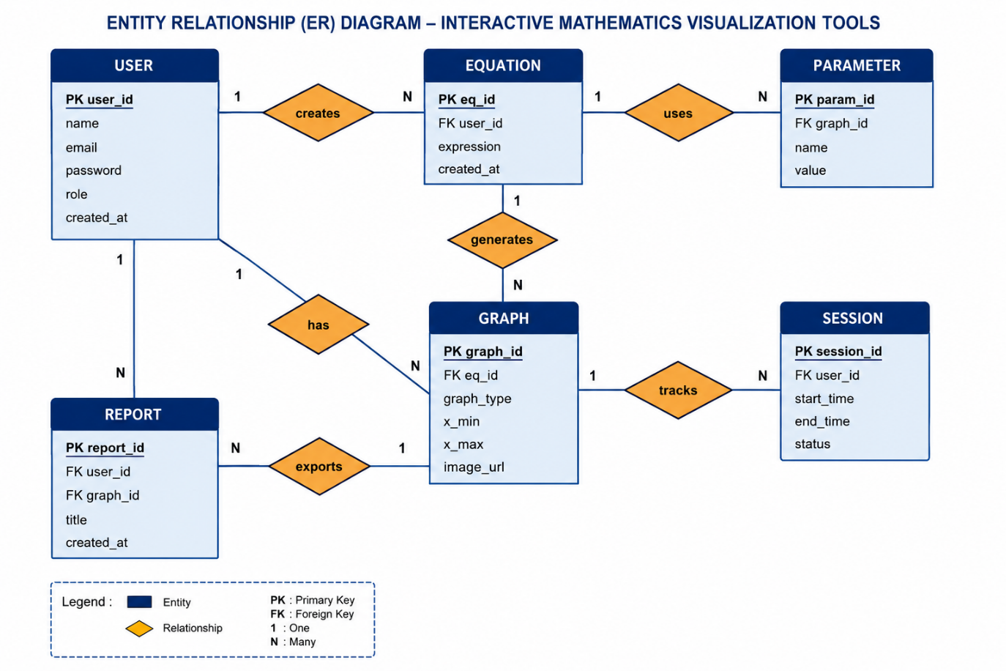
[Pragraph]

System FlowChart
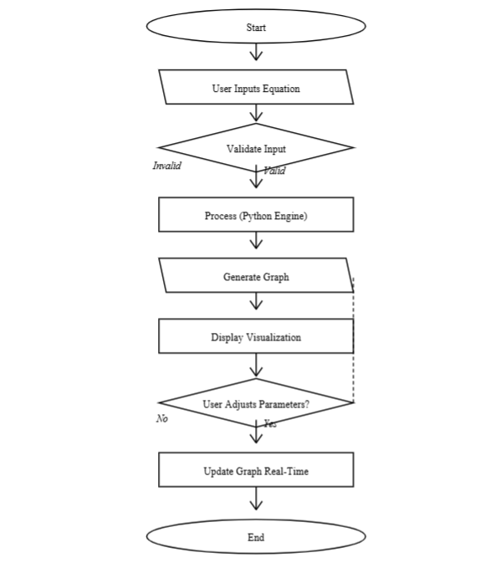
[Pragraph]

GANTT CHART
Task | Week 1 | Week 2 | Week 3 | Week 4
Requirement Analysis
System Design
Development
Testing
Deployment & Documentation

explain

EXPECTED OUTCOMES
paragraph
- A fully functional interactive visualization tool
- Improved understanding of mathematical concepts
- Increased student engagement
- User-friendly educational software
- Real-time graphical representation of equations

CONCLUSION
The proposed "Interactive Mathematics Visualization Tools" project aims to address the limitations of traditional, static learning methods by leveraging the power of Python and web-based frameworks. By bridging the gap between abstract mathematical theory and visual conceptualization, this system will empower students to explore complex functions through real-time experimentation. Ultimately, this tool serves as a modern pedagogical solution that fosters deeper cognitive engagement, improves problem-solving efficiency, and makes advanced mathematics more accessible and intuitive for both students and educators.

